Chapter 8 Review Quiz

Instructions:
Do not submit this document. You will be answering these questions on our course Mastering Geology page. Use this document to mark your answers for quick reference.

1) Which of the following is not one of the agents of metamorphism?
A) pressure
B) heat
C) calcium-rich liquids
D) chemically active liquids

2) During metamorphism, what is the major effect of chemically active fluids?
A) They increase the pressures in deeply buried, regional-metamorphic zones.
B) They aid in the movement of dissolved silicate constituents and facilitate growth of the mineral grains.
C) They prevent partial melting so solid rocks can undergo very high temperature regional metamorphism.
D) They facilitate the formation of schistosity and gneissic banding in hornfels and slates.

3) The best clue for identifying the parent rock from which a metamorphic rock was derived is ________.
A) the temperature at which the metamorphism occurred
B) the depth at which the metamorphism occurred
C) the chemical composition of the metamorphic rock
D) the grade of metamorphism

4) ________ is a strong, parallel alignment of coarse mica flakes and/or of different mineral bands in a metamorphic rock.
A) Rock cleavage
B) Foliation
C) Stress streaking
D) Marbleizing

5) Metamorphic rocks that contain large crystals embedded in a finer grained matrix have a ________ texture.
A) gneissic
B) foliated
C) slaty
D) porphyroblastic

6) What major change occurs during metamorphism of limestone to marble?
A) Calcite grains grow larger and increase in size.
B) Clays crystallize to micas, forming a highly foliated, mica-rich rock.
C) Limestone grains react to form quartz and feldspars.
D) Calcite grains are dissolved away leaving only marble crystals.
7) Which of the following lists the rocks in the order of increasing grain size and increasing grade of metamorphism?
A) phyllite, slate, schist
B) schist, slate, phyllite
C) slate, phyllite, schist
D) slate, schist, phyllite

8) Foliation in metamorphic rocks is mainly evident in the parallel alignment of certain mineral grains. What are they?
A) micas
B) garnets
C) feldspars
D) quartz

9) Which metamorphic rock, widely used for monuments and buildings, would deteriorate significantly in contact with acid rain?
A) quartzite
B) sandstone
C) marble
D) slate

10) Which of the following best describes the conditions of contact metamorphism?
A) Pressures are very high, the rock is deeply buried, and temperatures are raised by the Earth's internal heat.
B) Pressures are fairly low, the rock is in the upper part of the crust, and heat is supplied from a nearby magma body.
C) Heat is generated by shearing and mechanical movements along faults.
D) Depths are fairly shallow, but temperatures and pressures are so high that the rocks begin to partially melt.

11) In which setting would regional metamorphism be most likely?
A) at shallow depths below an oceanic ridge or rift zone
B) at shallow depths along major transform faults in the continental crust
C) at great depths in the crust where two continents are colliding
D) at shallow depths beneath the seafloor where water pressures are immense

12) Burial metamorphism would be most likely to occur in which of the following environments?
A) at a subduction zone
B) after a meteorite impact
C) at a mid-ocean ridge
D) a subsiding basin

13) ________ can provide good indication of the metamorphic environment in which a rock formed.
A) Migmatites
B) Index minerals
C) Hydrothermal solutions
D) Micas

14) Carefully examine the photograph below of a metamorphic rock sample. The sample is shown as its actual size.

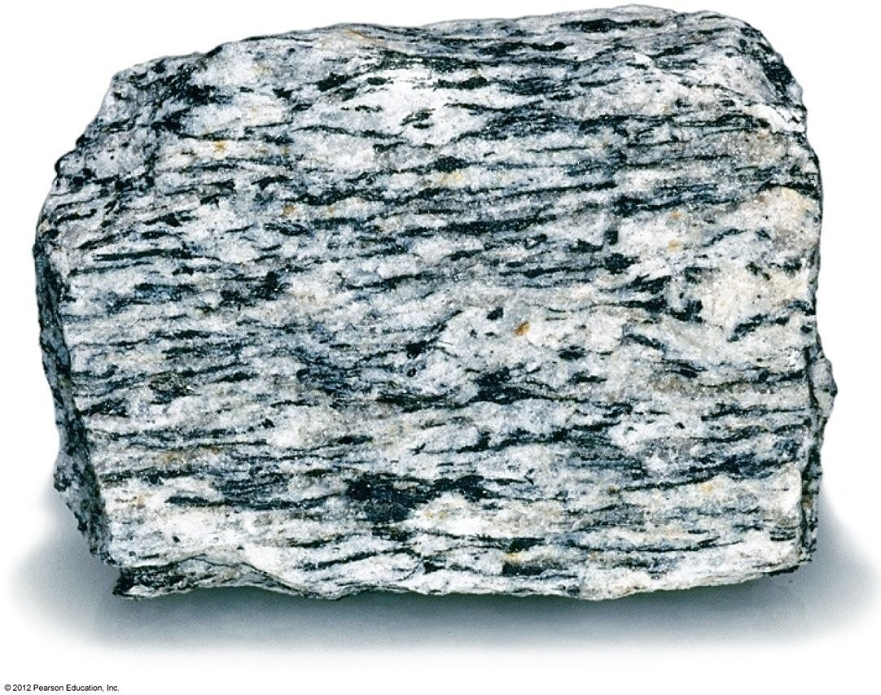

This rock is
A) foliated
B) non-foliated

15)
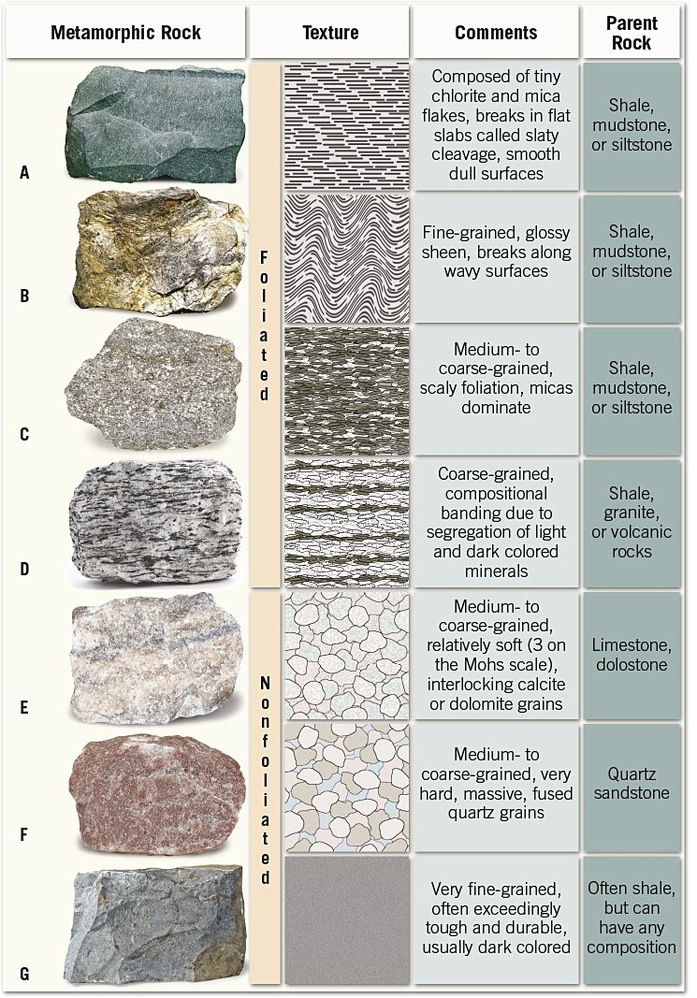

Match the rock names with the appropriate label.

gneiss; phyllite; quartzite; slate; hornfels; marble; schist

